Personal Profile

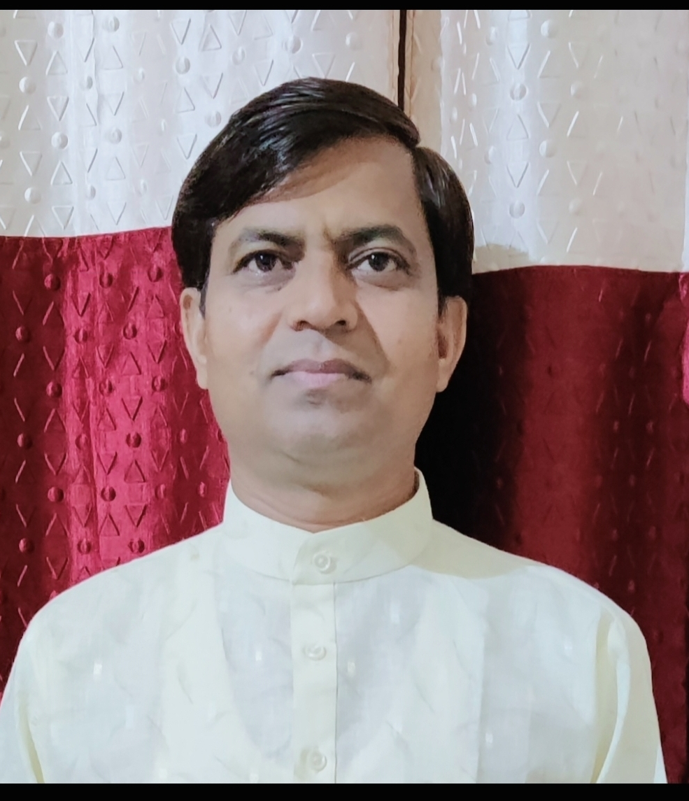 Dr.Om Prakash Bairwa
Associate Professor
Department of Sanskrit
Government P.G.College, Jhalawar-326001
(Rajasthan) INDIA
E-Mail – omprakashbairwa4773@gmail.com
Educational qualifications- Ph. D.
Date of birth- July 04, 1973
Contact No- 9414191704
TEACHING EXPERIENCE: ➢
Undergraduate and postgraduate courses since 03-12-2002.
RESEARCH FIELD: ➢Sanskrit
PUBLICATION : ➢ 03 Research papers published in National &International journals.

